Jira Software Your work vFilters v Dashboards v People v Apps v

Projects / Customer Care Registry / CCR board Reports

# Burndown Chart

CCR sprint 2 Issue Count  How to read this chart

|  |
| --- |
| Q Search |

|  |
| --- |
| • Guideline  Remaining Values  Non-Working Days  O Show Non-Working Days |

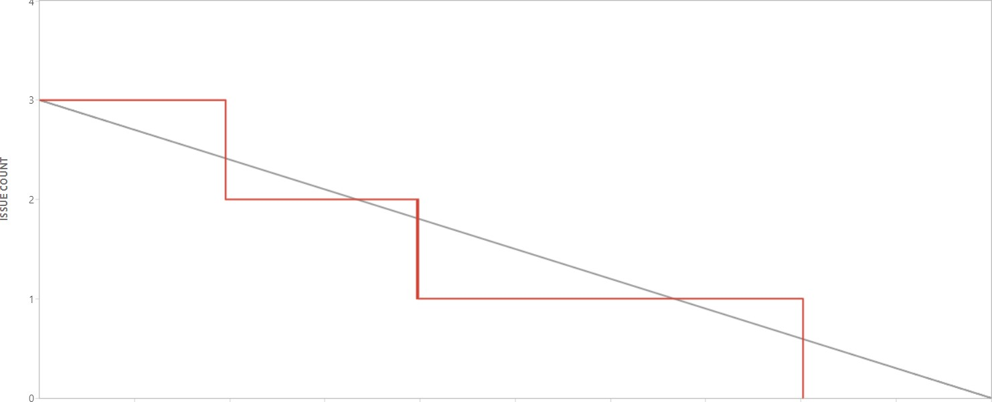4



Projects

Oct 31 12:00 Nov 1 0:00 Nov 1 12:00 Nov 2 0:00 Nov 2 12:00 Nov 3 0:00 Nov 3 12:00 Nov 4 0:00 Nov 4 12:00 Nov 5 9:00

TIME

Issue Count

